PROGRAM – 38, 39

HARINI. R

192324108

38. Write a LEX program to validate DOB of students.

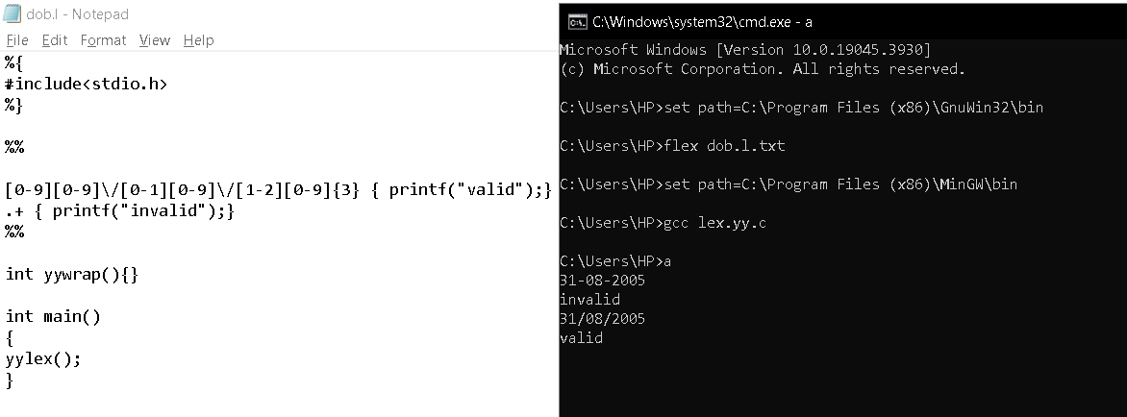

39. Write a LEX program to implement basic mathematical operations.

